**Idea 1: Personal Finance Tracker**

User can update income and expenses via the app and be able to see a dashboard of User’s finance situation.

* Expenses should include details like (i) date, (i) amount, (iii) description, (iv) category of expense.
* Tracker should include:
  + Current Balance
  + Set Budget for each category
  + Total expenditure, Expenditure by category, Expenditure by Day (bonus ++ Graphs or Pie Charts).

**Database Design and ER Diagram**

Features

* Single User Application
* Filter
* Dashboard

**Keys and Properties**

|  |  |  |  |  |
| --- | --- | --- | --- | --- |
| **Income** | **Expense** | **Budget** | **Savings** | **Category** |
| Income ID | Exp_ID | Budget_ID | Income ID | Category_ID |
| Category | Category | Category ID | Expense ID | Category Name |
| Amount | Amount | Budget Amount | Amount added |  |
| Description | Description | Refresh_Date | Amount deducted |  |
| Timestamp | Timestamp | Description | Balance |  |
|  | Budget ID | Budget Used |  |  |
|  |  | Budget left |  |  |
|  |  | Expense ID |  |  |

ERD

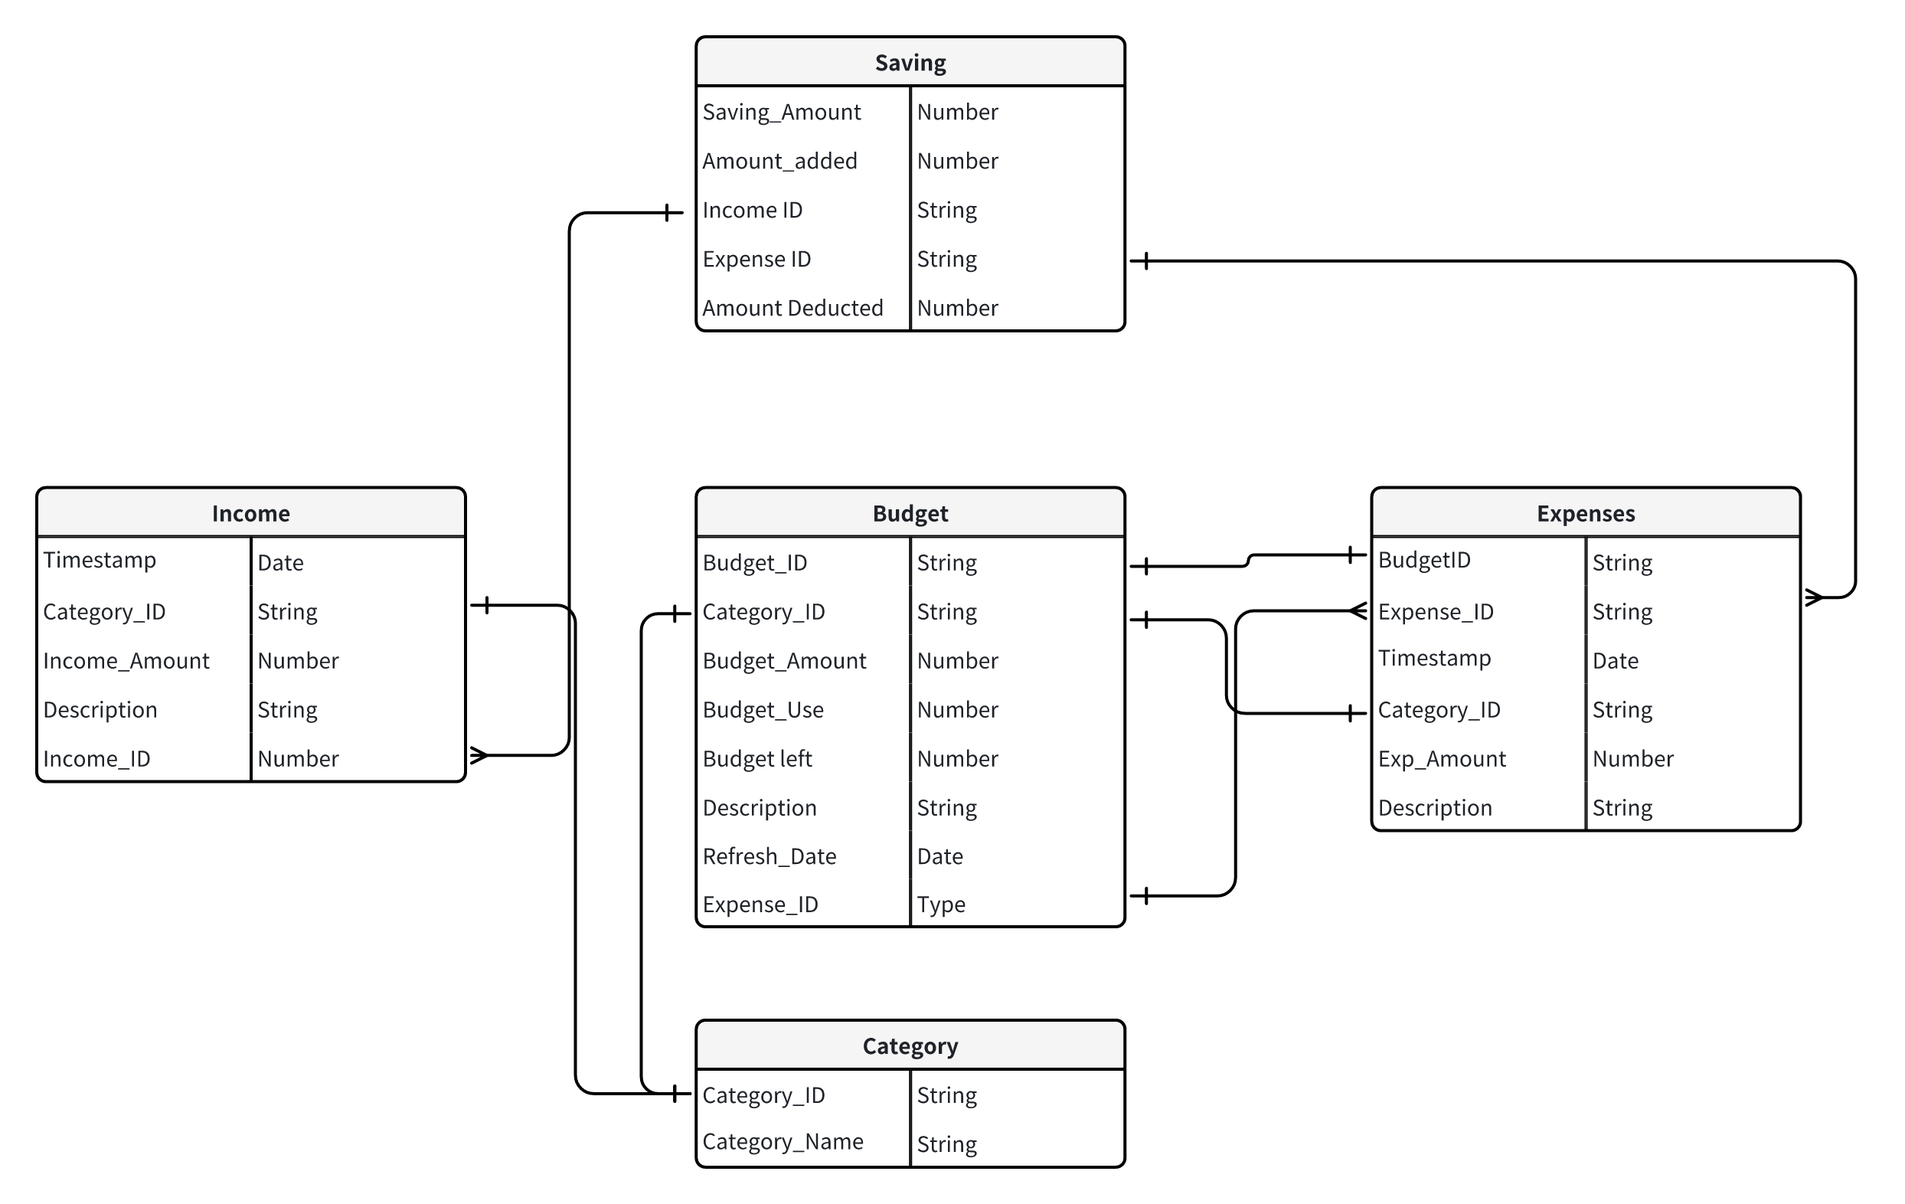

Wireframe

